Date of Incident: |  | Time of Incident: AM/PM
Participant Name: |  | Location of Incident:
Supervisor Notified:____________________

Staff Name: ______________________ Date:________________________ Time:__________________
Type of Incident  ____ Injury:  ____ Participant ___Staff ___Visitor  ____ Damage:  ____ DeRiche Property ____ Personal Property  ____ Vehicle ____ Other_____________  ____ Infectious/Contagious Disease | Classification of Incident (check any that apply):  ____SIB _____Attention Seeking ____Security _____Other  _____Minor _____ Mild ______ Moderate _____Major
Location of Injury to:__________________________
Mark on the figures the general area of any cuts, scratches, marks or bruises possibly relating to the incident/accident.

____ Medication Issue:  ____ error  ____adverse drug reaction, food/drug interaction  ____Property Loss  ___ Participant absence  ___ Other _______________________________ | 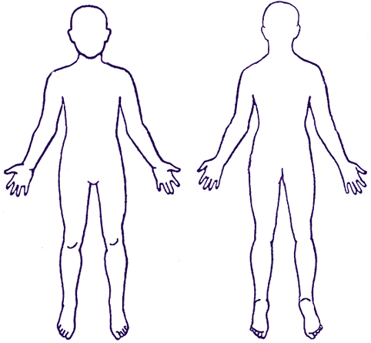
Other Person(s) Involved Participant, Staff, Visitor, please use first name or initials only:
DeRiche Agency, Inc.

Internal Incident Report

Report must be completed by employee within 24 hours of incident. If incident involves more than one participant, fill out separate report for each.

A. Description of Incident

Was anyone injured? Was first aid needed? Who? Describe.
What happened before the incident took place?
What happened during the incident?
What occurred right after the incident?
Why did the incident occur?
What did you do?

Name of person completing this Incident/Accident form ________________________________________________
Date

B. Review: Recommendations for Follow-up
________________________________________________________________________________________________________________________________________________________________________________________________________________________________________________________________________________________________________________________
_______________________________________________________
Printed Name Person Reviewing Report:

_____________________________________________________ _______________________
Full Signature/Title Date

